Milestone 4 – Completed Functionalities with Screenshots
FOR

BI DASHBOARD WEB APPLICATION
SUBMITTED TO
IVTECH COMPUTER SYSTEMS LLC

Version: 1.1

14th JULY 2025

Prepared By:
SPEC INDIA
Revision History

Date | Version | Author | Created / Updated / Reviewed / Verified / Approved By
14-07-2025 | 1.1 | Parth Jotangiya | - Initial Draft
14-07-2025 | 1.1 | Yaman Kavishwar | - Reviewed and approved

Table of Contents
Contents
1. Introduction 4
1.1. Items in the Scope 4
2. Detailed Screenshots for Each Functionality 5
2.1 License (Admin) Web App (Customer Licensing details, generating license) (Partial) 5
2.2 Data Ingestion (Partial) 5
2.3 BI Dashboard Web Application - Dashboard Widgets (Partial) 6
2.4 Dashboard Reports Filtering 39
2.5 Settings (Upload Customer Logo) 42
2.6 Map Integration 42

Introduction

- This document serves as a comprehensive summary of all the functionalities that were planned, developed, and completed as part of Milestone 4 for the License & BI Dashboard Web Application project. It includes detailed information about each feature, covering its objective, scope, and expected behavior.
- Each functionality is thoroughly described and supported with annotated screenshots to visually demonstrate successful implementation. These visual validations help in ensuring that the delivered features align with the requirements and offer clarity for future reference, testing, or client verification.

Items in the Scope

Sr. No | Functionality Title | Description | Status
1 | Admin Web App (Customer Licensing details, generating license) (Partial) | - Manage customer and distributor details.  - Generate and email licenses to distributors. | Completed (covered in milestone #3)
2 | Data Ingestion (Remaining) | - Scheduled using cron jobs at specific intervals.  - Ability to replicate data from camera devices. | Completed (covered in milestone #3)
3 | Dashboard Widgets | - Implementation of widgets under the Camera, Site, People, and Retail categories. | Completed
4 | Dashboard Reports Filtering | - Users can apply filters based on Floor Plan, Zone, and Date Range to load data on the specific dashboard. | Completed
5 | Settings (Upload Customer Logo) | - Allows authorized users to upload their company logo. That uploaded logo will be displayed on middle of header section. | Completed
6 | Map Integration | - Allows authorized users to configure their own Google Map API Key.  - View and configure the Map Plan widget on the dashboard. | Completed

Detailed Screenshots for Each Functionality

License (Admin) Web App (Customer Licensing details, generating license) (Partial)

The License Web Application is a centralized platform designed to efficiently manage user access, licensing, and customer-distributor relationships for software license products. It allows authenticated users to securely log in, while super users can create and manage sub-users with specific roles and permissions through a flexible role-based access control system. This ensures that each user only has access to the features and data relevant to their responsibilities.

In addition, the application streamlines customer and distributor management by allowing users to store and maintain essential contact and business details. One of its key features is the ability to generate and email software licenses directly to distributors, enhancing operational efficiency and reducing manual errors. This functionality makes the system ideal for organizations seeking a secure, scalable, and user-friendly solution for license management.

Here is the link of created Figma Design for License Web Application: Click Here

IMPORTANT NOTE:
Initially, it was planned to deliver the License Web Application partially under Milestone 3. However, due to changes in the execution plan and a comprehensive flow of requirement gathering, all associated features and functionalities were finalized at the very first stage. As a result, we’ve successfully developed the complete License (Admin) Web.

Data Ingestion (Partial)

The system includes a feature that automatically makes specific API calls in the background at predefined time intervals to ingest data into the database. The ingested data is then displayed on the BI Dashboard Web Application.

Since this is a fully automated background process with no user interaction, no permission management is required or handled by the system for this feature.

IMPORTANT NOTE:
Initially, it was planned to deliver this component partially under Milestone 3. However, due to changes in the execution plan and a more comprehensive flow of requirement gathering, we have successfully developed all the necessary cron jobs required for replicating data from the camera devices. These background processes will play a crucial role in supporting the development of associated features and functionalities within the upcoming BI Dashboard Web Application.

Screenshots:

- Data ingestion is managed through a set of defined cron jobs/schedulers that execute at specific intervals to ensure timely and automated data processing.
- We have implemented the following cron jobs in the system to replicate data from the camera devices, enabling consistent and reliable synchronization between the devices and the platform.

BI Dashboard Web Application - Dashboard Widgets (Partial)

The BI Dashboard Web Application is a platform designed with key foundational modules to support user access control and device management. It includes a secure, credential-based user authentication system, and a comprehensive role and permission management structure that allows super users to create and manage sub-users with varying levels of access based on assigned roles.

Additionally, core functionalities have been developed for camera and AI box management, enabling authorized users to add, update, or remove devices. The system features floor plan and zone management, allowing users to define layouts and associate specific areas with camera zones. A camera-to-zone configuration module has also been implemented to map devices to their respective zones. Furthermore, the application supports multi-site management for deployments across multiple locations. Users can track and acknowledge generated events, configure system settings, and customize their dashboard by adding or removing widgets as needed.

Here is the link of created Figma Design for BI Dashboard Web Application:
- Light Theme: Click Here
- Dark Theme: Click Here

IMPORTANT NOTE:

Milestone 4 includes the delivery of the following features:

- Implementation of widgets under the
  - Camera category:
    - Camera Online/ Offline
    - Model Types
    - Feature Types
  - Site category:
    - Capacity Utilization for People
    - Capacity Utilization for Vehicle
    - Zone Wise Capacity Utilization for Vehicle
    - Zone Wise Capacity Utilization for People
  - People category:
    - Slip & Fall Detection
    - People In & Out
    - Average People Counting
    - People Count by Gender
    - Cumulative People Count
    - New Vs Total Visitors
    - Safety Measures
    - Zone Wise People Counting
    - People Counting Heatmap
  - Retail category:
    - Shopping Cart Counting
    - Queue Events for Shopping Cart
    - Queue Events for People
    - Shopping Cart Heatmap
    - Block Exit Detection

1) Camera category - Camera Online/ Offline

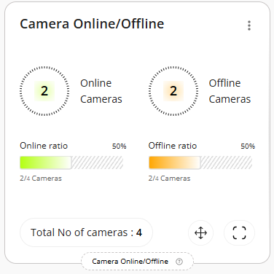
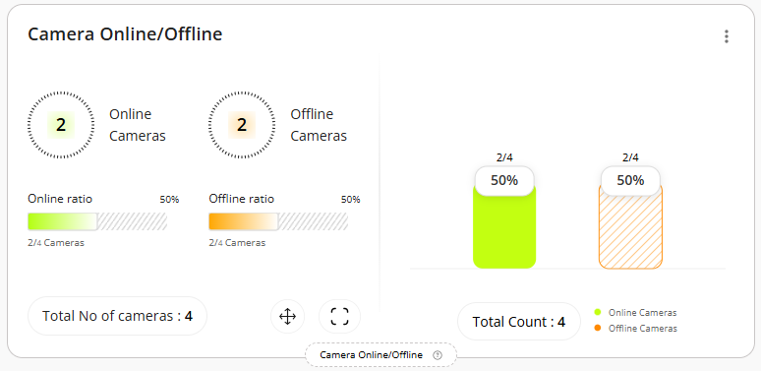
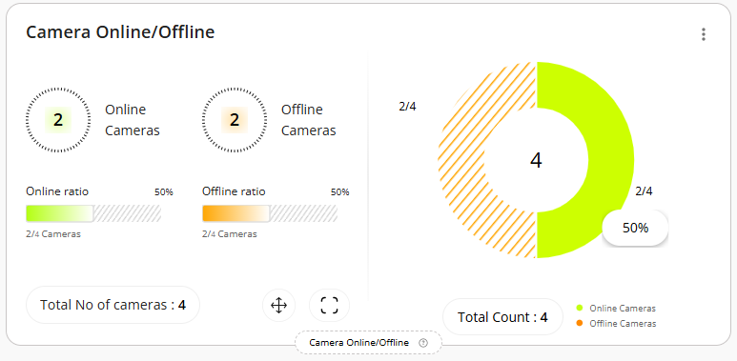
2) Camera category - Model Types

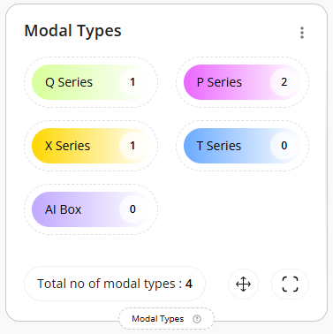
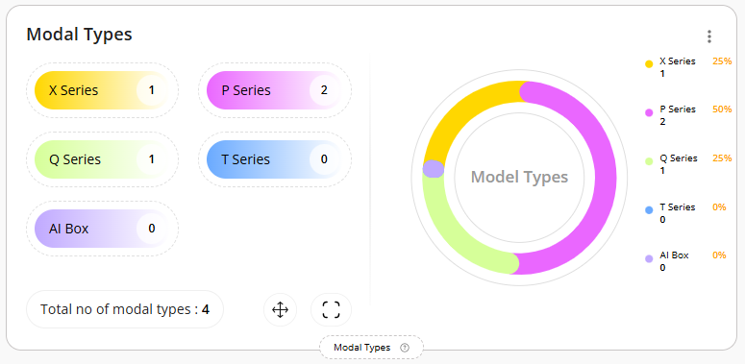
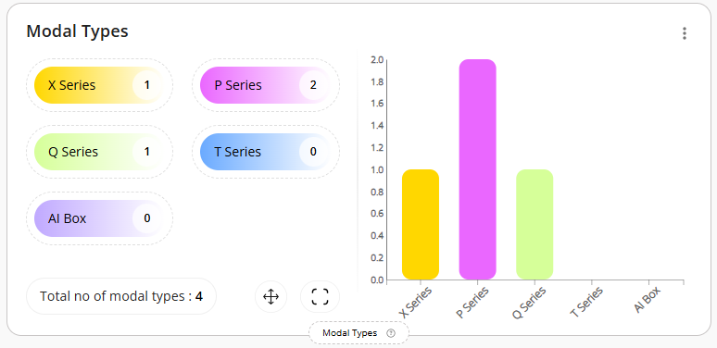

3) Camera category - Feature Types

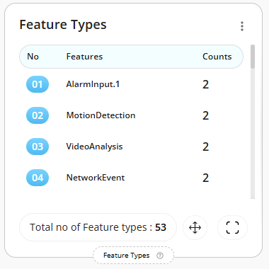
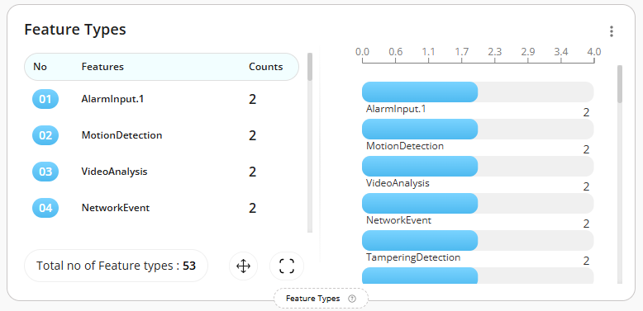
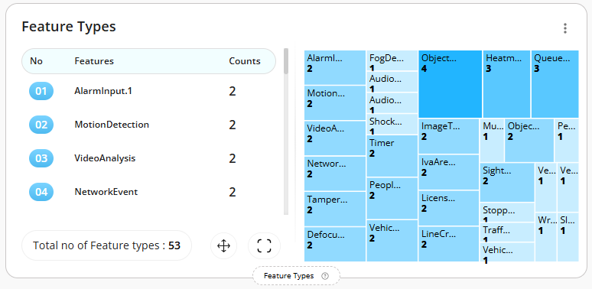
4) Site Category- Capacity Utilization for People

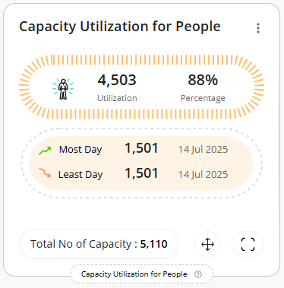
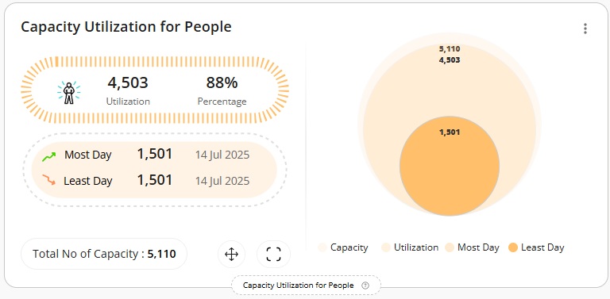
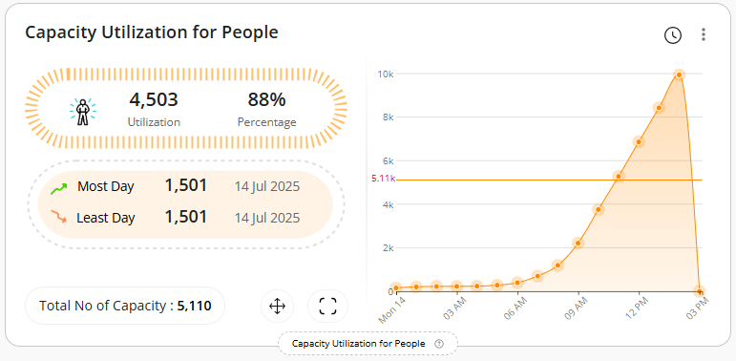
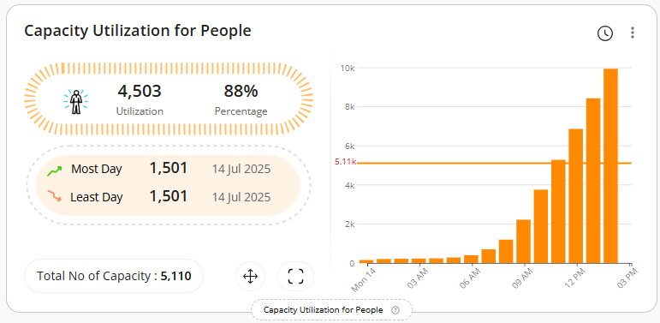
5) Site Category- Capacity Utilization for Vehicle

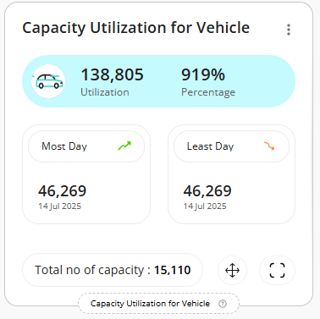
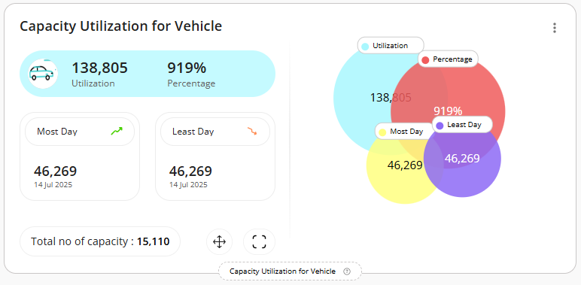
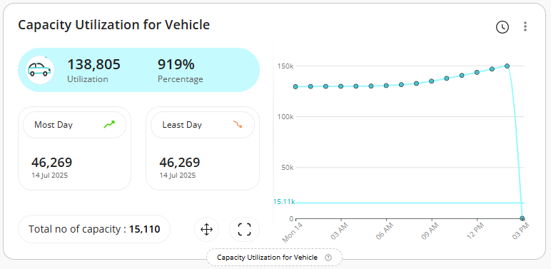
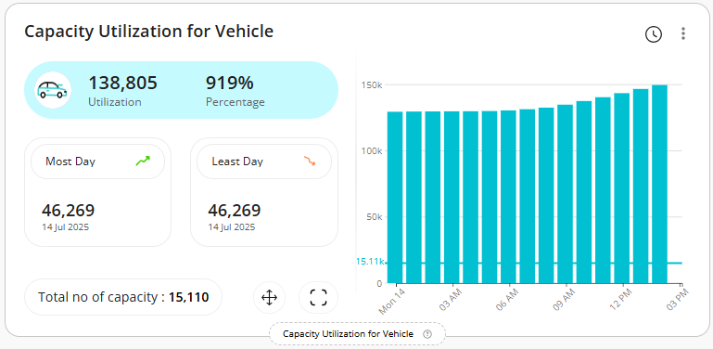
6) Site Category- Zone Wise Capacity Utilization for Vehicle

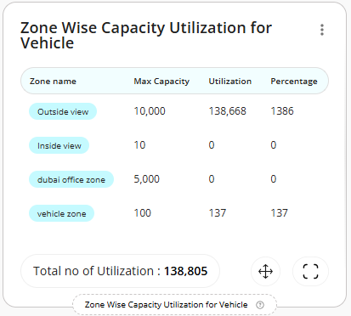
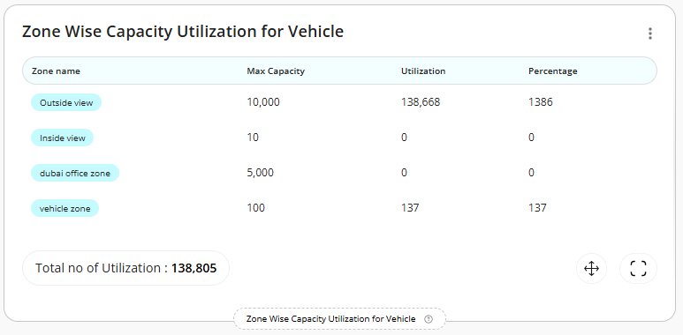
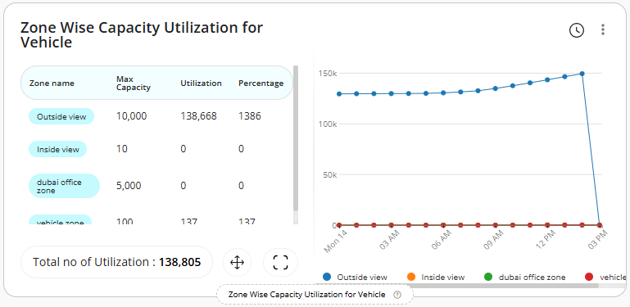
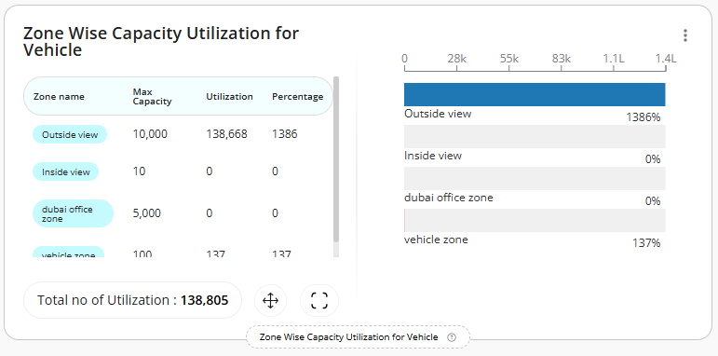
7) Site Category- Zone Wise Capacity Utilization for People

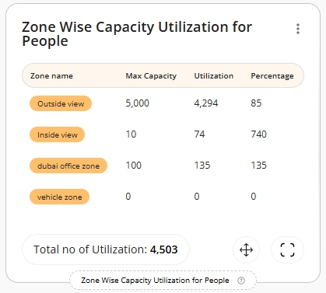
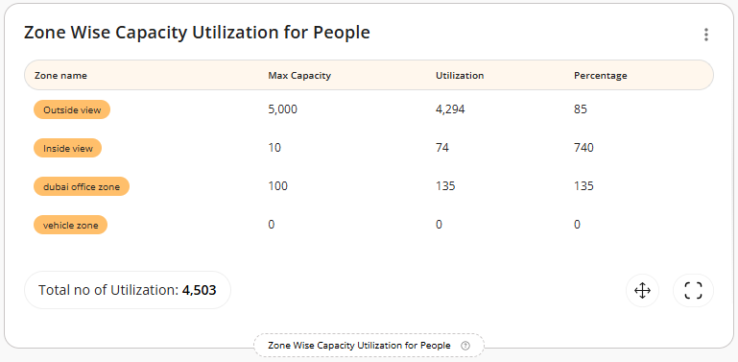
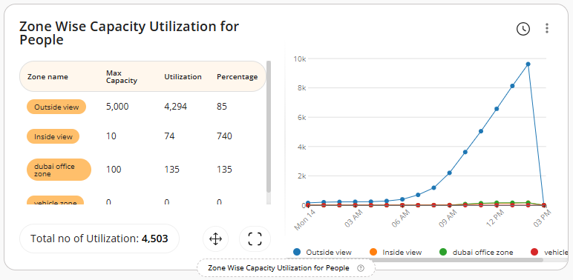
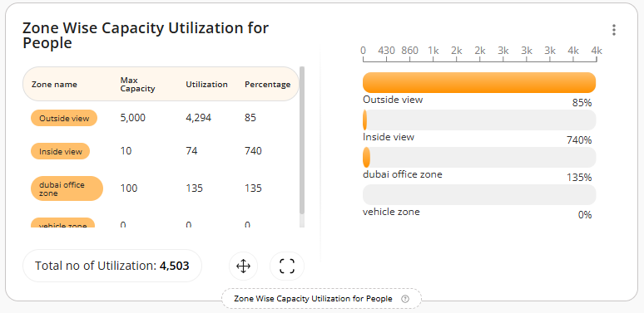
8) People Category- Slip & Fall Detection

- Currently, we are not receiving any events for this. As a result, you may not see any data displayed in the widgets below.
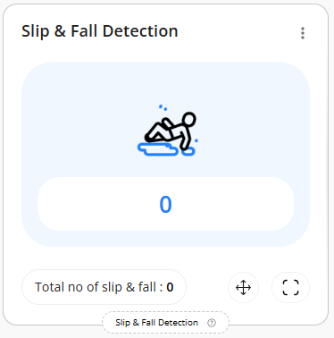
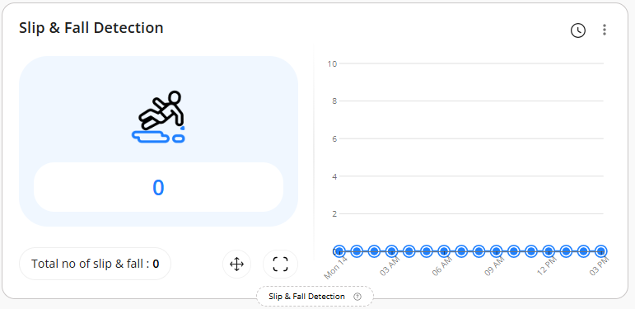
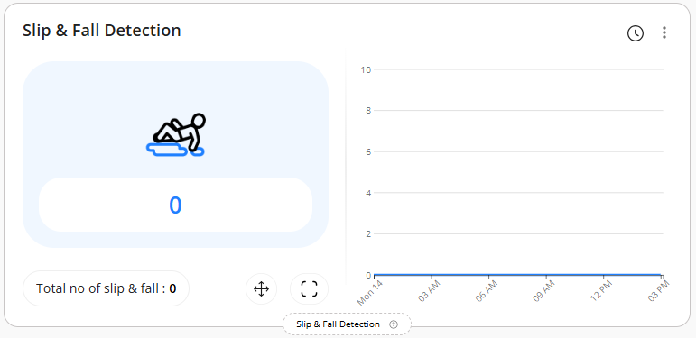

9) People Category- People In & Out

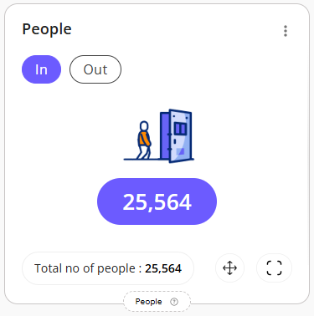
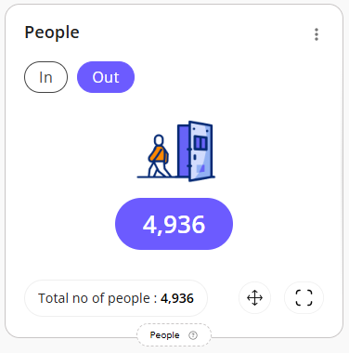
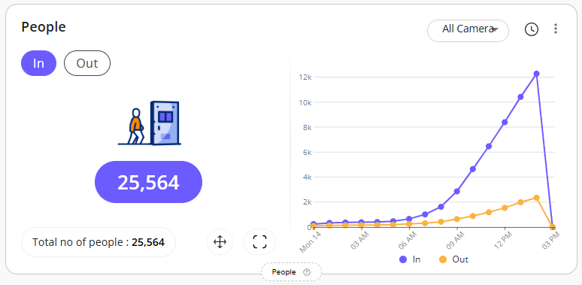
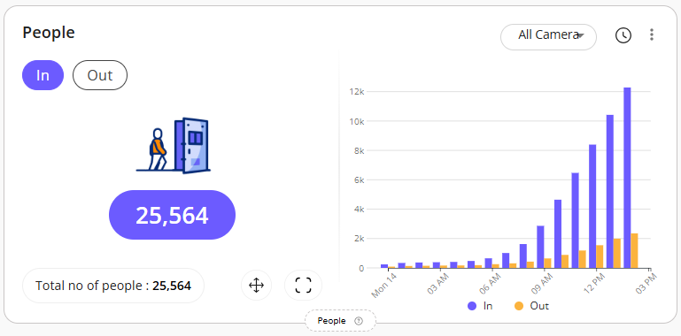

10) People Category- Average People Counting

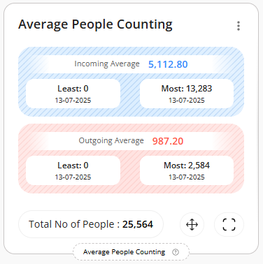
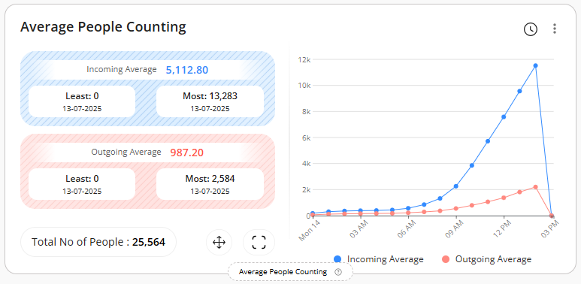
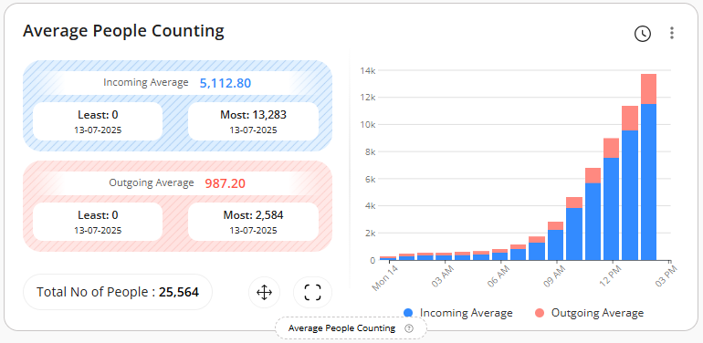
11) People Category- People Count by Gender

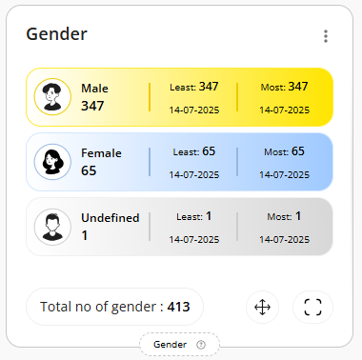
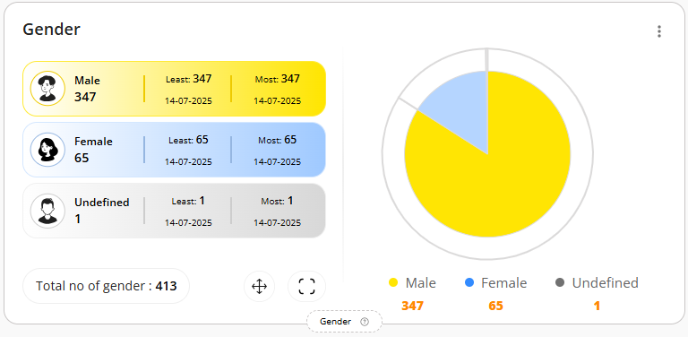
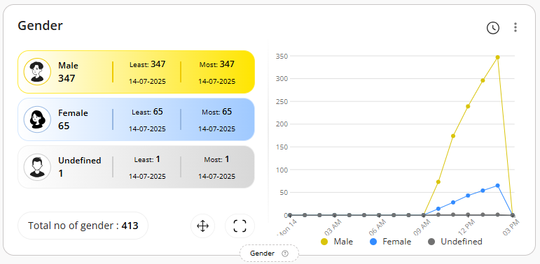
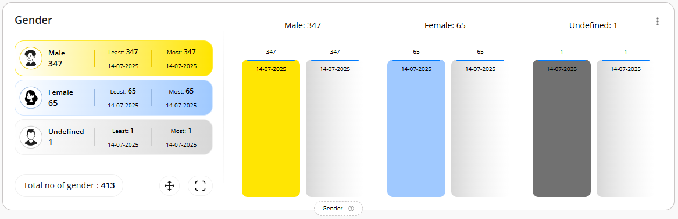
12) People Category- Cumulative People Count

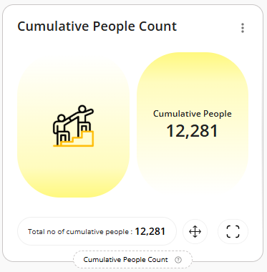
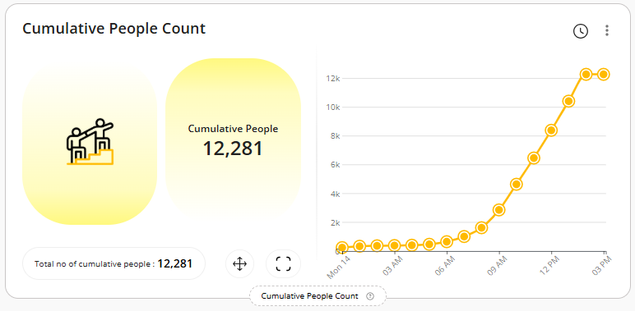
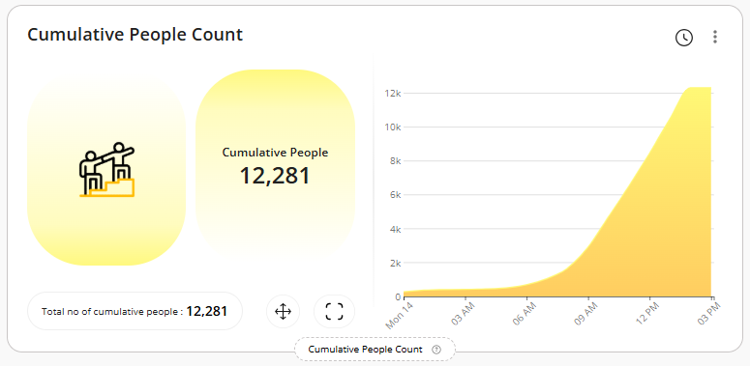
13) People Category- New Vs Total Visitors

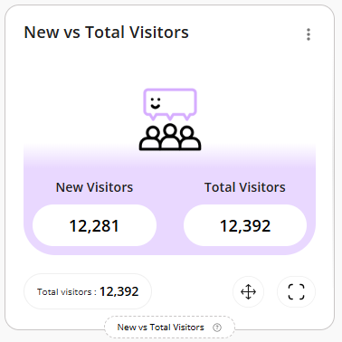
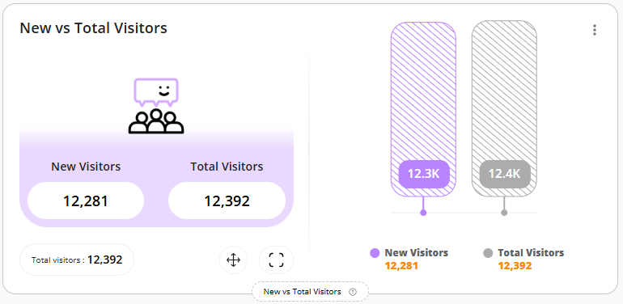
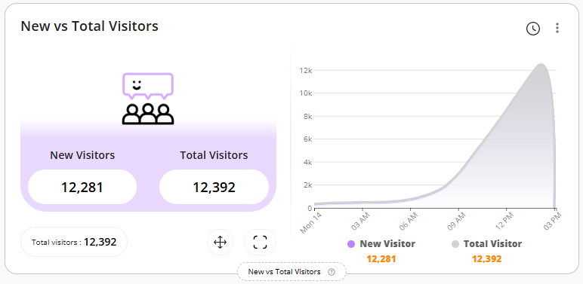
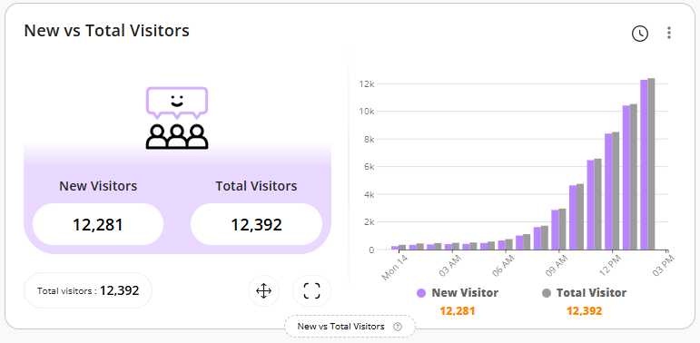
14) People Category- Safety Measures

- Currently, we are not receiving any events for this. As a result, you may not see any data displayed in the widgets below.
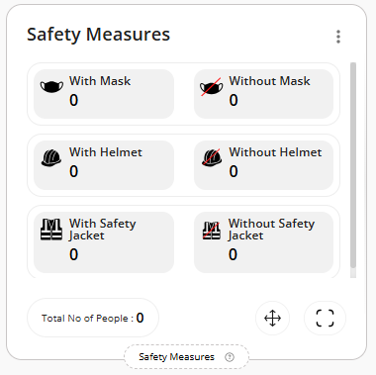
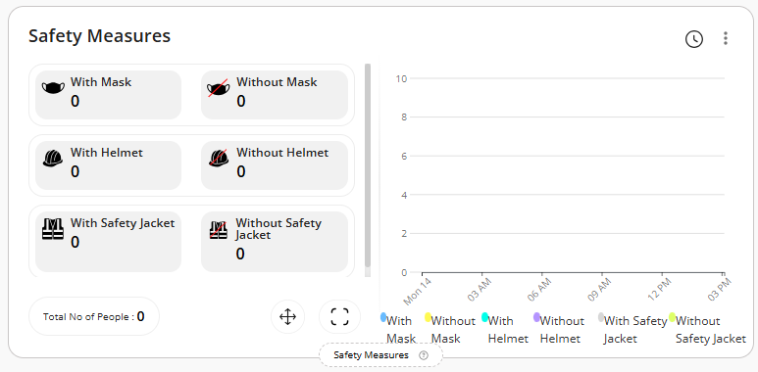
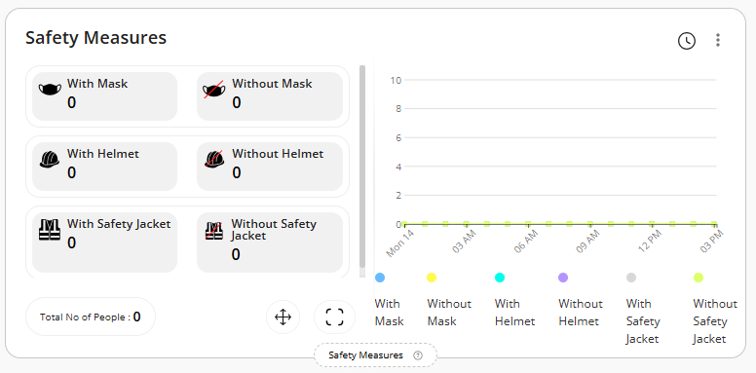

15) People Category- Zone Wise People Counting
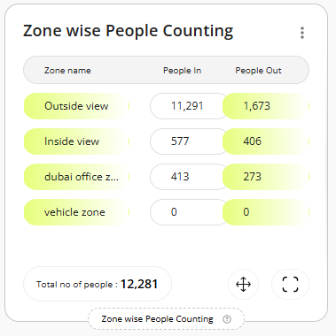
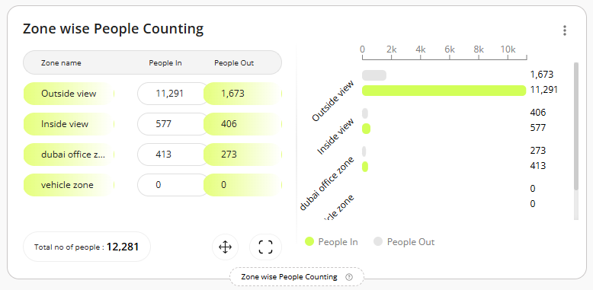
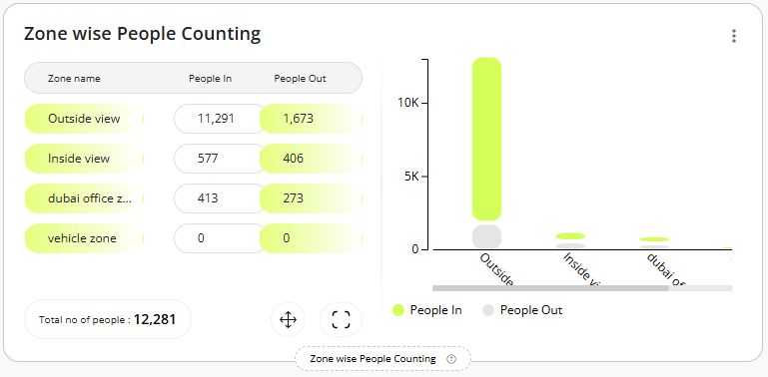
16) People Category- People Counting Heatmap

- Currently, we are not receiving proper data from the API, which is why we are unable to capture a screenshot of these widgets. However, please be assured that the functionality has already been developed and was showcased to the team during the internal demo call.

17) Retail Category- Shopping Cart Counting

- Currently, we are not receiving any data related to shopping cart from the camera APIs. As a result, you may not see any data displayed in the widgets below.
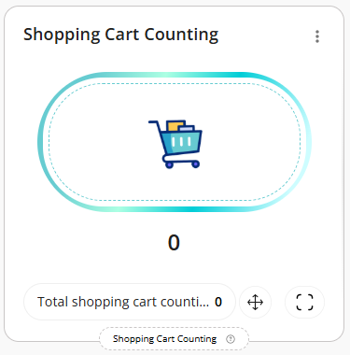
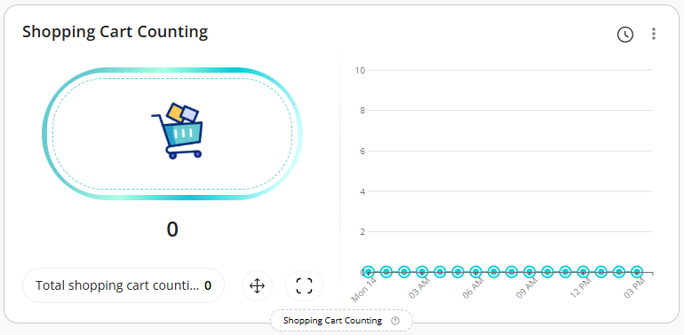
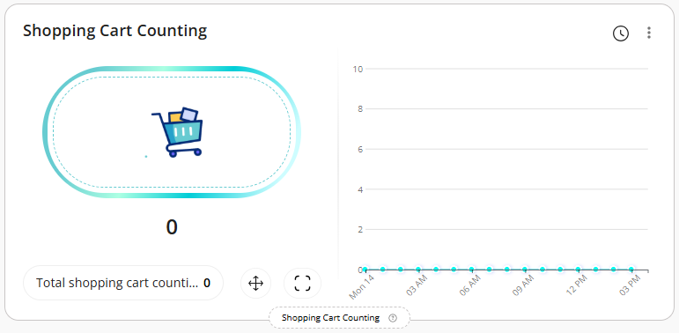

18) Retail Category- Queue Events for Shopping Cart

- Currently, we are not receiving any data related to shopping cart from the camera APIs. As a result, you may not see any data displayed in the widgets below.
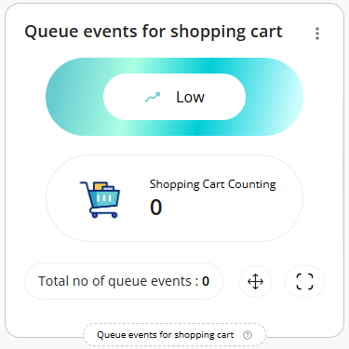
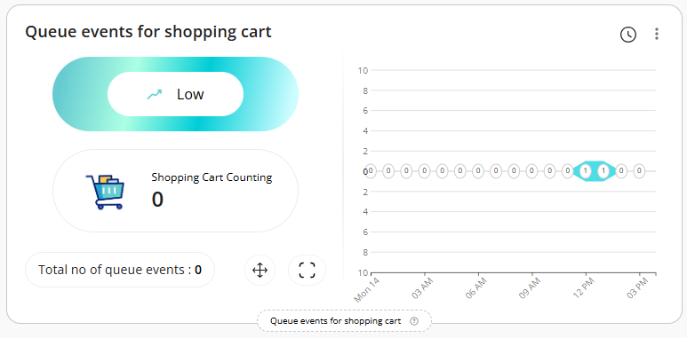
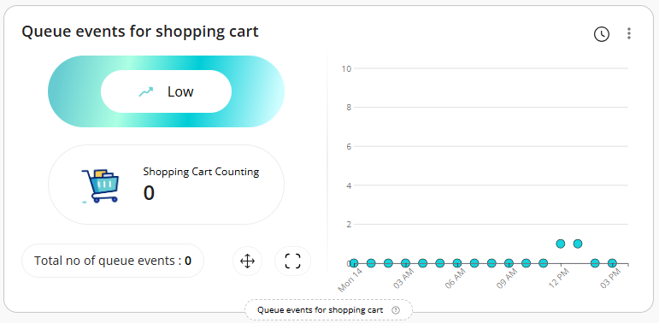
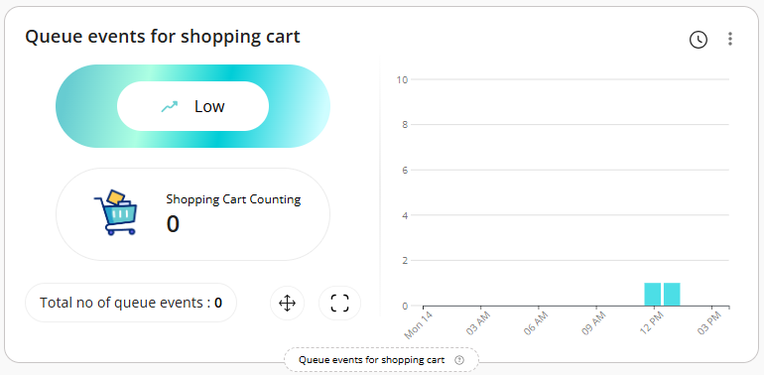

19) Retail Category- Queue Events for People

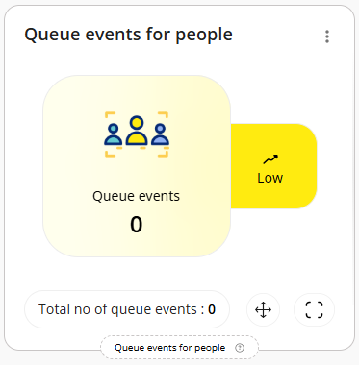
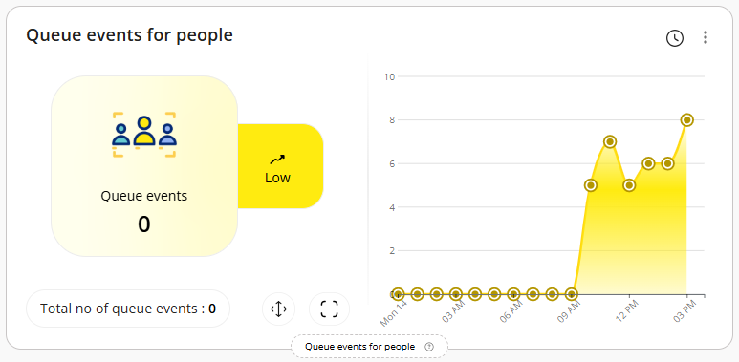
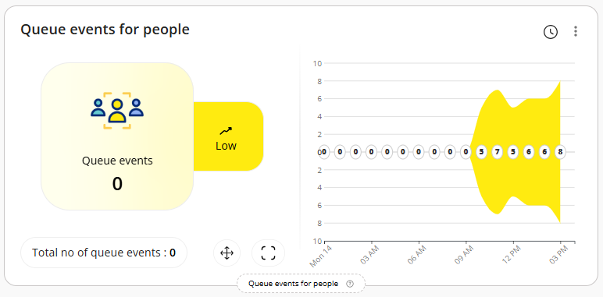
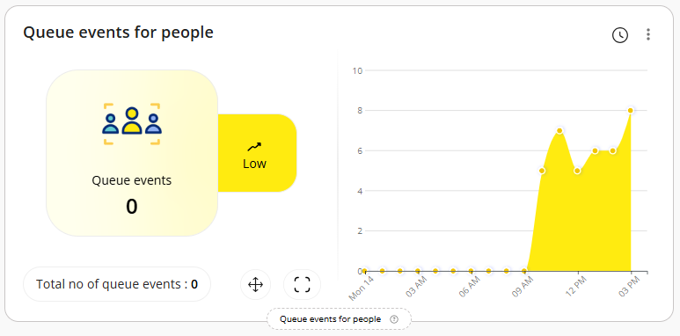
20) Retail Category- Shopping Cart Heatmap

- Currently, we are not receiving proper data from the API, which is why we are unable to capture a screenshot of these widgets. However, please be assured that the functionality has already been developed and was showcased to the team during the internal demo call.

21) Retail Category- Block Exit Detection

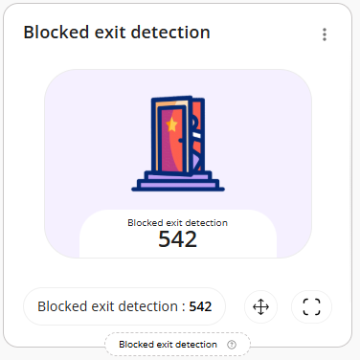
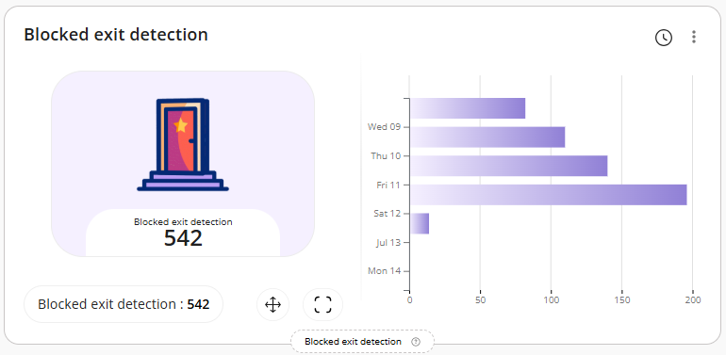
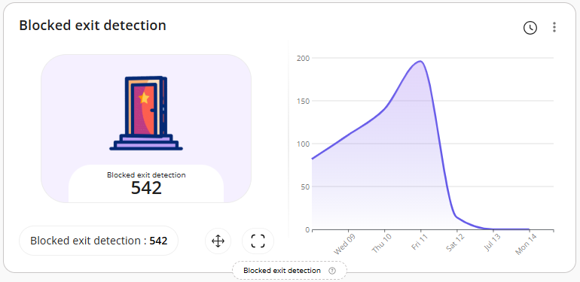
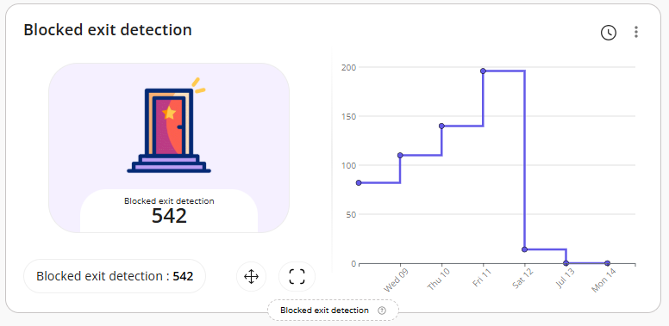

Dashboard Reports Filtering

The system allows authorized users to apply filters on specific dashboards to view detailed information from the configured widgets.

Users can apply the following filters:
- Select Floor Plans
- Select Zones
- Select Date Range

These filters help tailor the data displayed on the dashboard based on user preferences.

Attached are the screenshots for your reference:

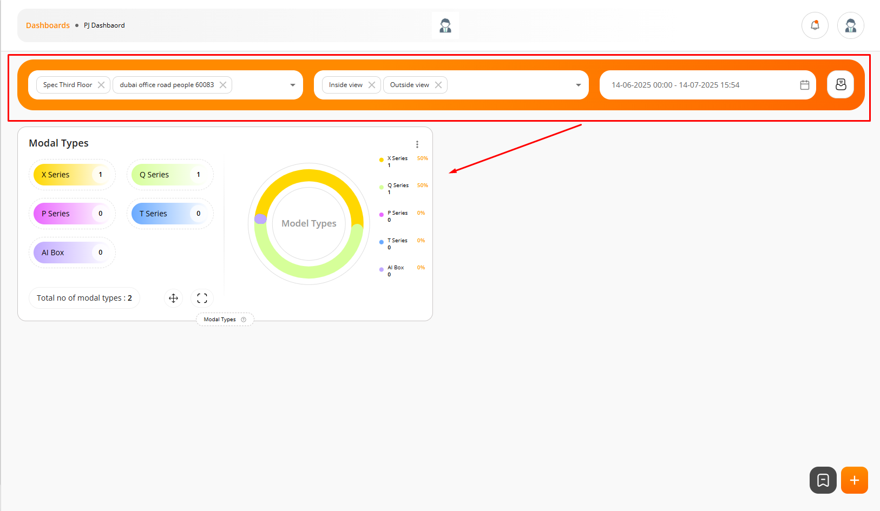
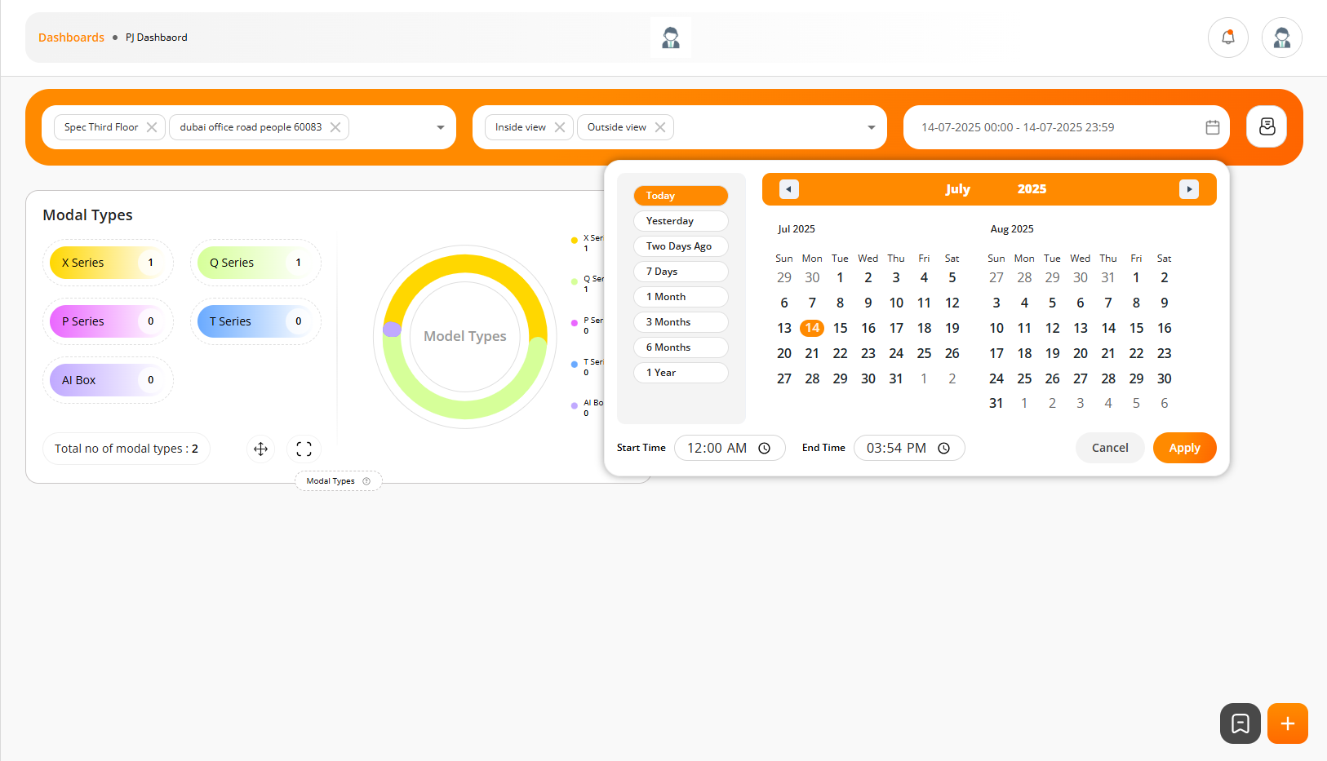
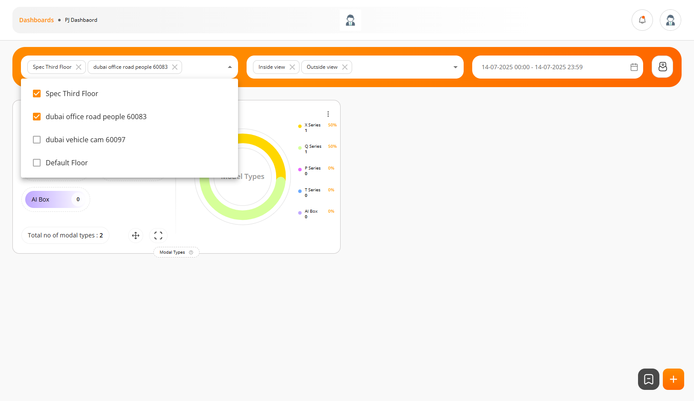
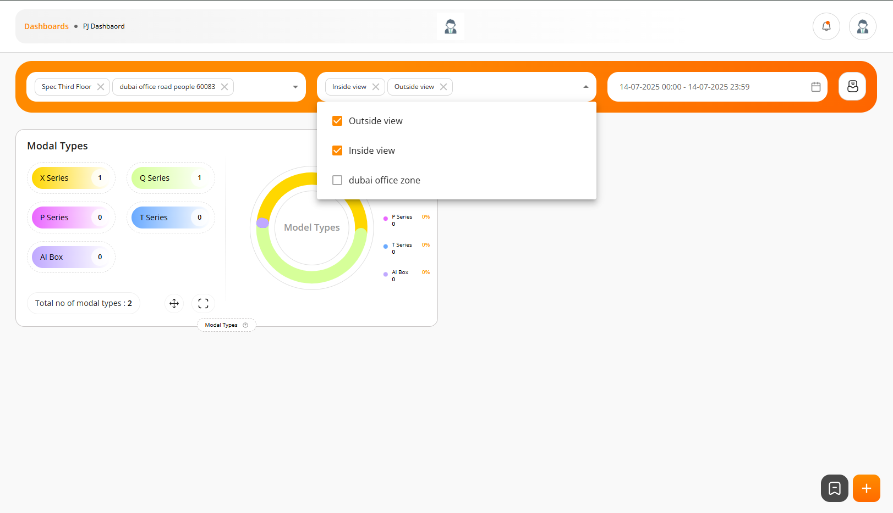

Settings (Upload Customer Logo)

The system allows authorized users to upload their company logo from the “Settings > General” page.

Once uploaded, the logo will be displayed at the center of the header section across the application.

Attached are the screenshots for your reference:

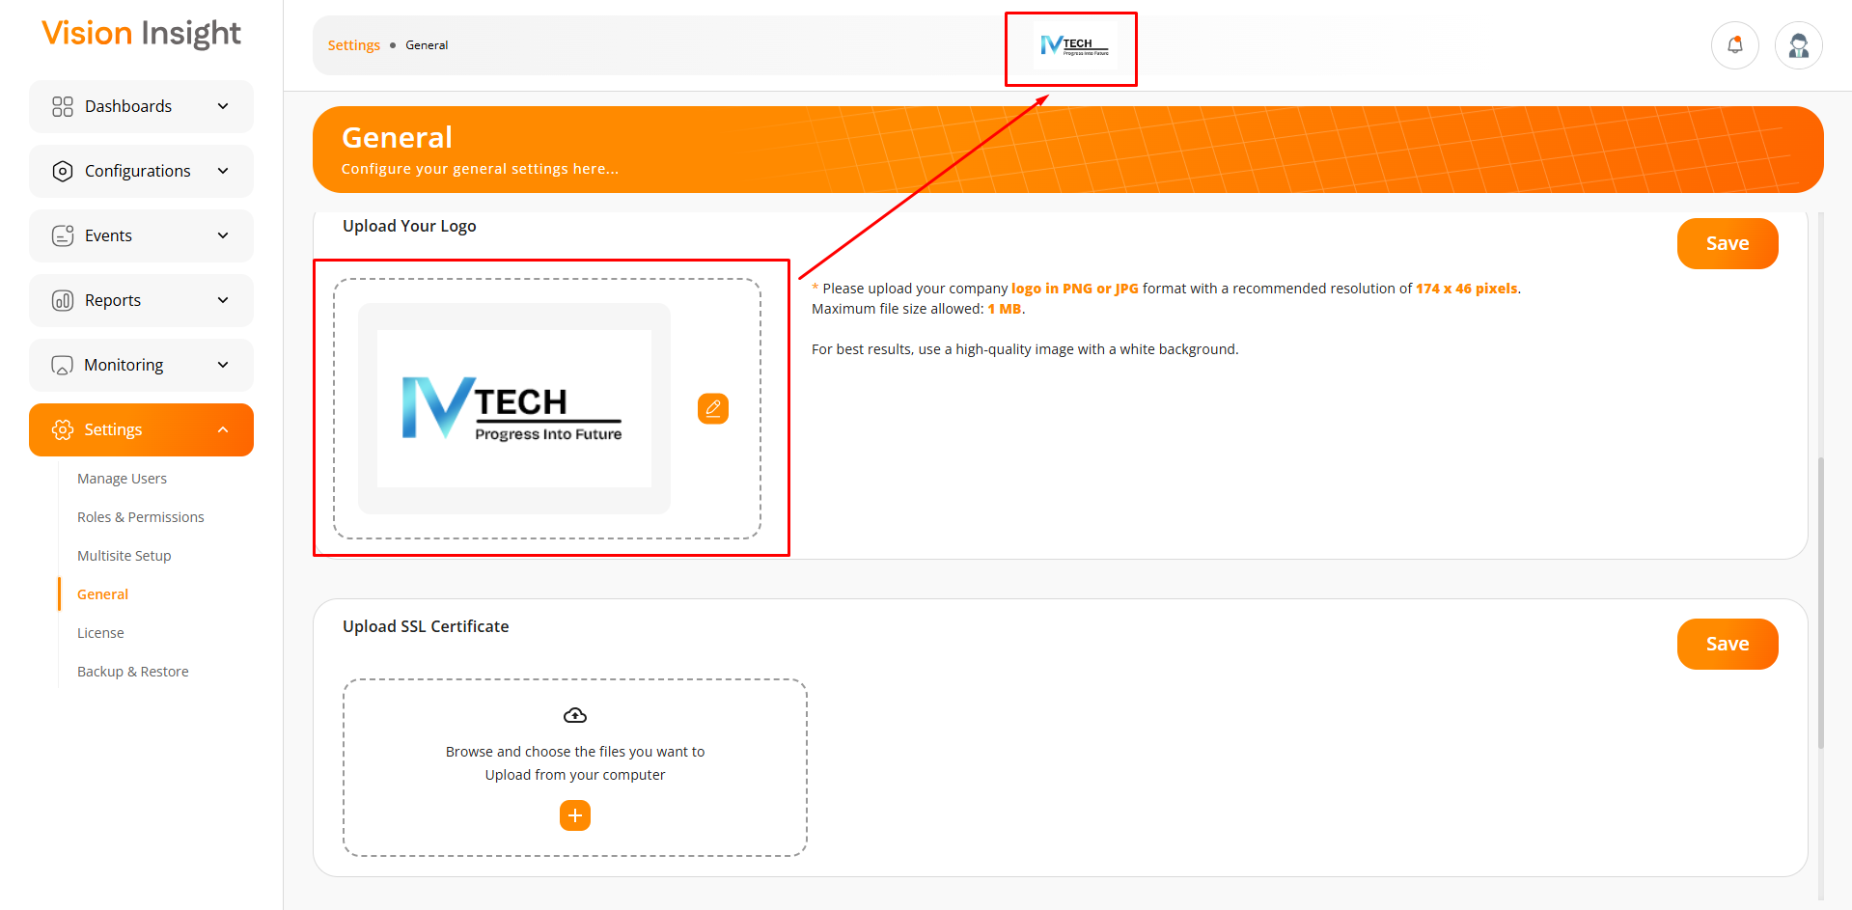

Map Integration

The system allows authorized users to configure their own Google Map API Key from the “Settings > General” page.

Once the key is configured, users can view and configure the Map Plan widget accordingly.

The system will validate the Google Map API Key during configuration and display an appropriate success or error message based on the validation result.

Attached are the screenshots for your reference:

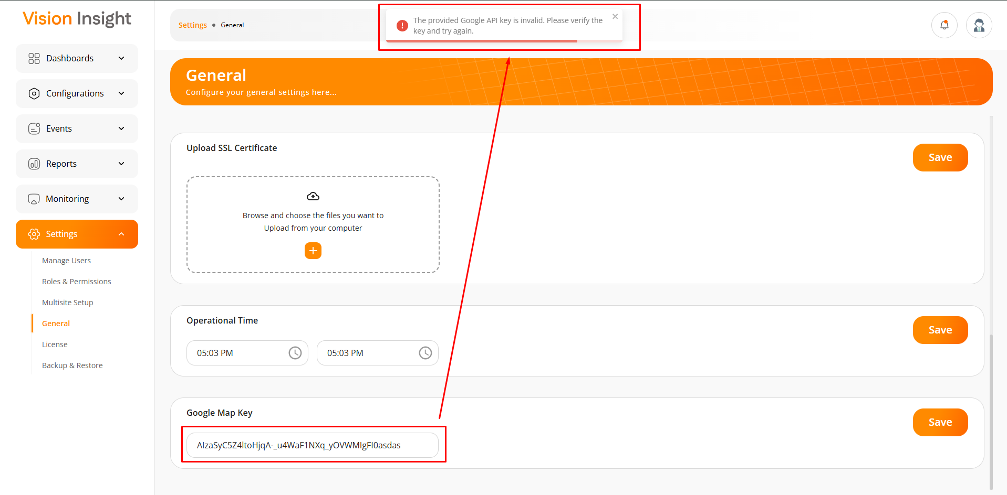
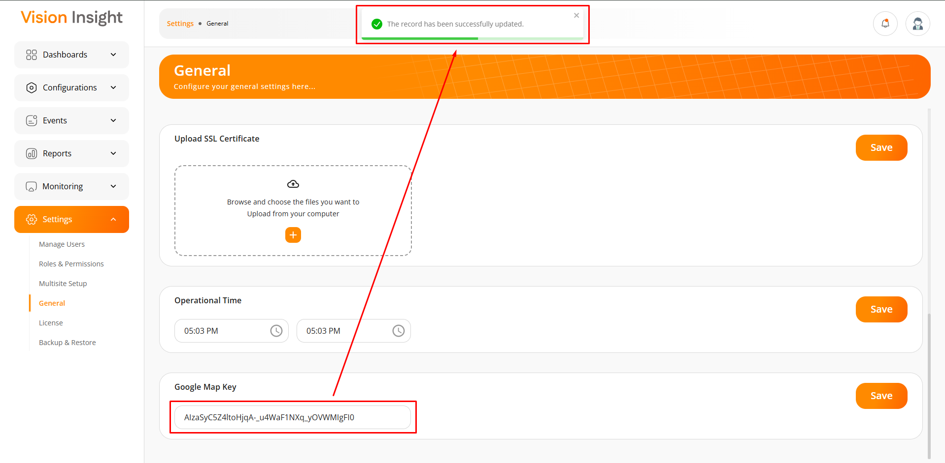
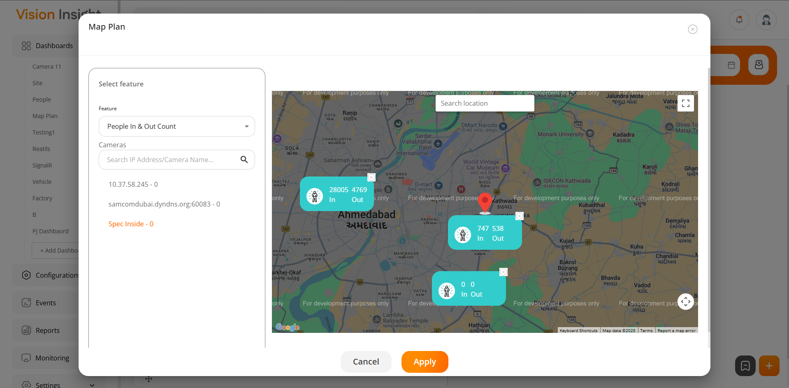
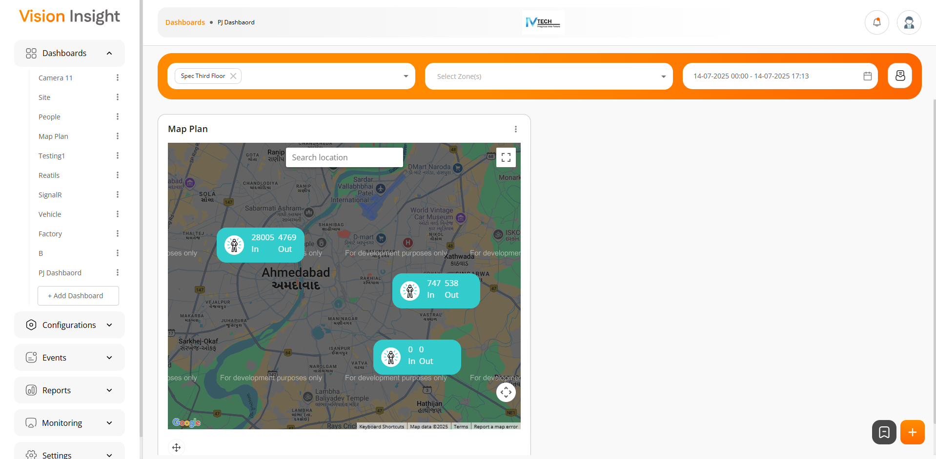

---- end of document ----

